**Spring core Assignment 1 - TanayaJadhav**

**Q1)**

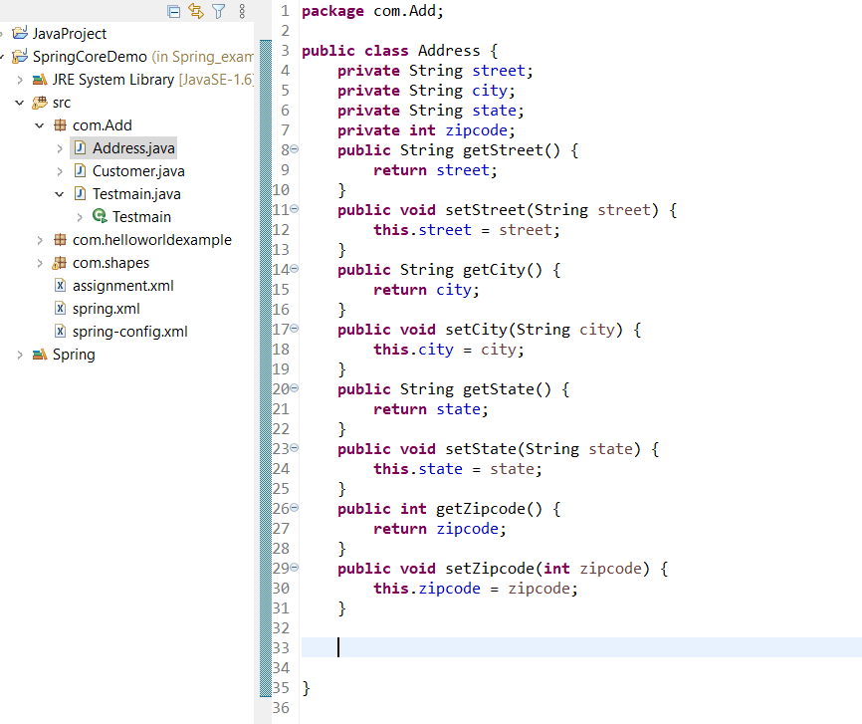

Address.java

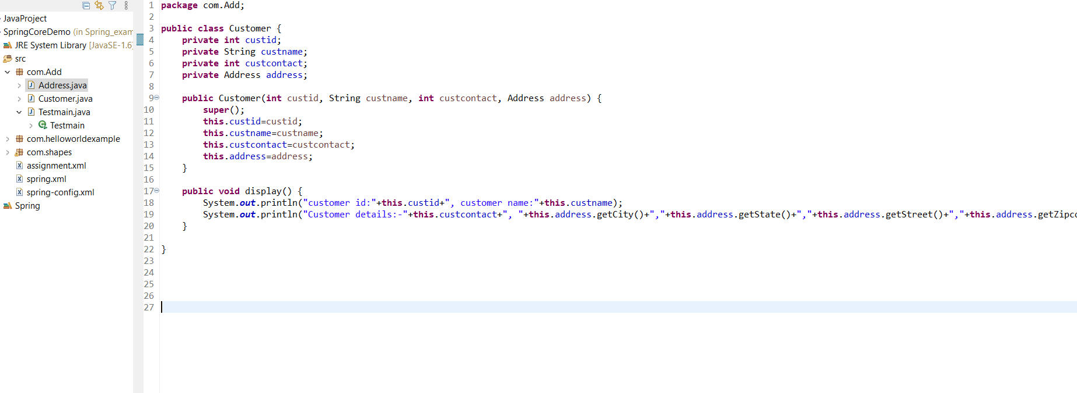

Testmain.java

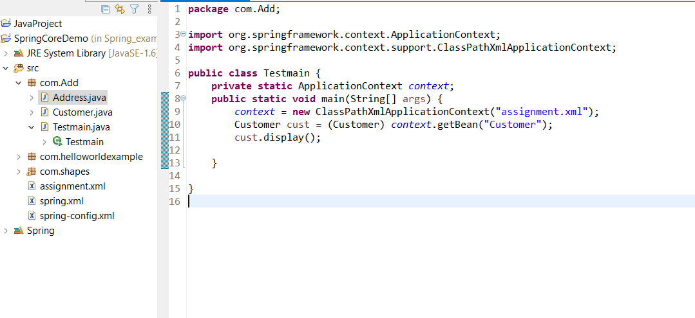

Assignment.xml

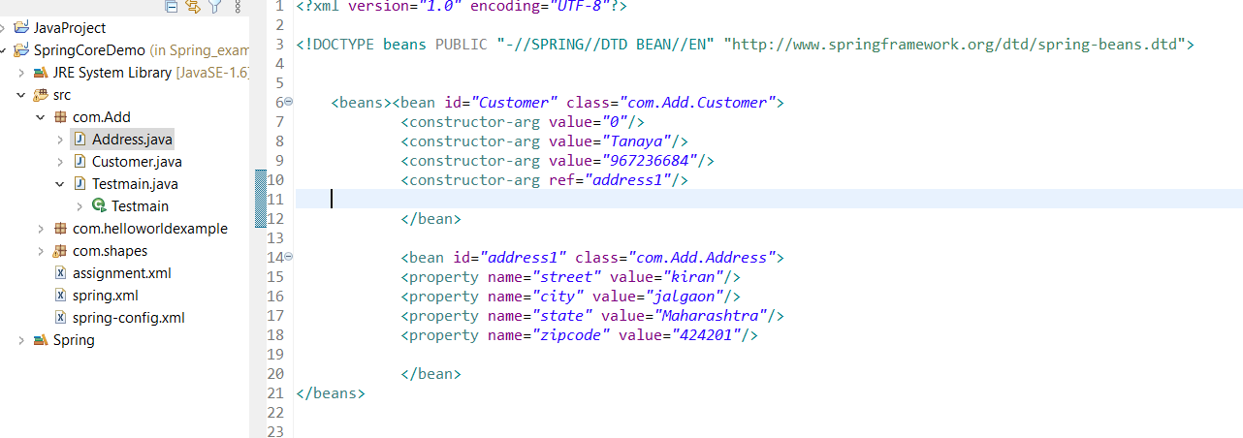

Aug 16, 2021 12:51:50 PM org.springframework.context.support.AbstractApplicationContext prepareRefresh

INFO: Refreshing org.springframework.context.support.ClassPathXmlApplicationContext@311d617d: startup date [Mon Aug 16 12:51:50 IST 2021]; root of context hierarchy

Aug 16, 2021 12:51:50 PM org.springframework.beans.factory.xml.XmlBeanDefinitionReader loadBeanDefinitions

INFO: Loading XML bean definitions from class path resource [assignment.xml]

Aug 16, 2021 12:51:50 PM org.springframework.beans.factory.support.DefaultListableBeanFactory preInstantiateSingletons

INFO: Pre-instantiating singletons in org.springframework.beans.factory.support.DefaultListableBeanFactory@2833cc44: defining beans [Customer,address1]; root of factory hierarchy

customer id:0, customer name:Tanaya

Customer details:-967236684, jalgaon,Maharashtra,kiran,424201

2)

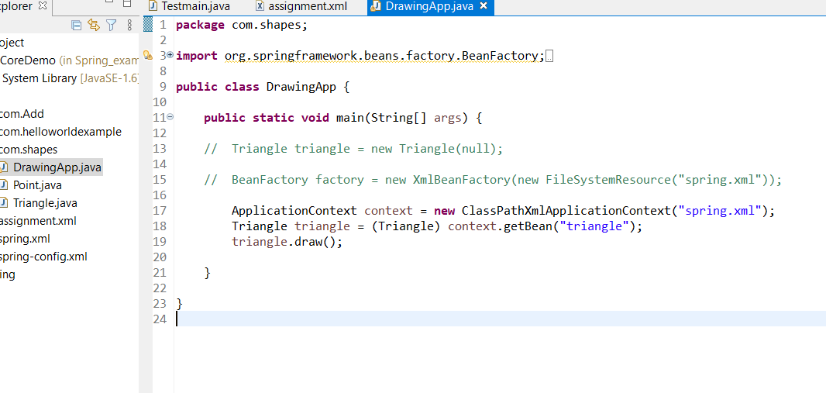

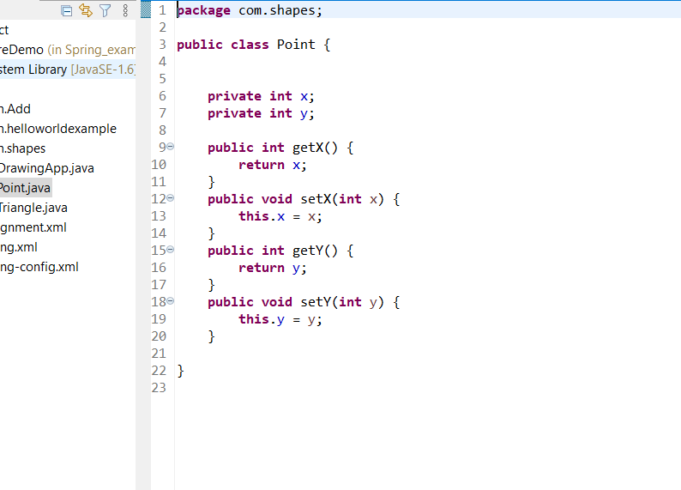

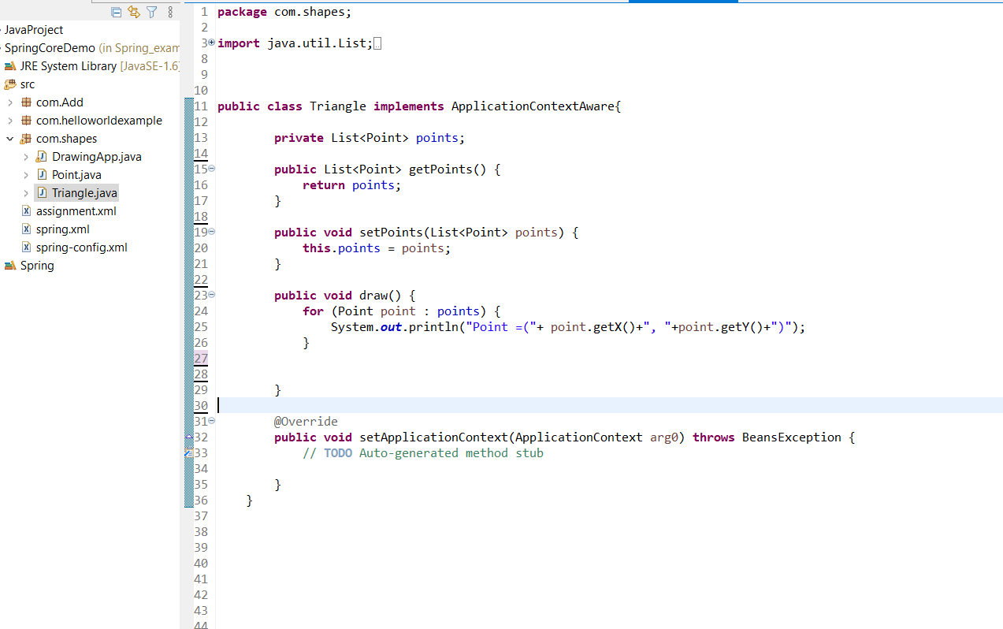

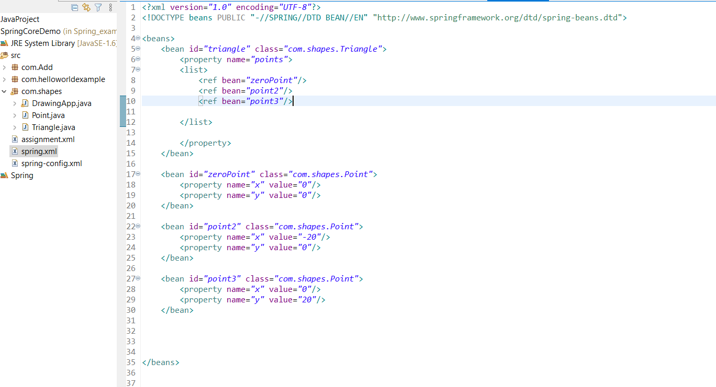

Aug 16, 2021 1:05:32 PM org.springframework.context.support.AbstractApplicationContext prepareRefresh

INFO: Refreshing org.springframework.context.support.ClassPathXmlApplicationContext@311d617d: startup date [Mon Aug 16 13:05:32 IST 2021]; root of context hierarchy

Aug 16, 2021 1:05:32 PM org.springframework.beans.factory.xml.XmlBeanDefinitionReader loadBeanDefinitions

INFO: Loading XML bean definitions from class path resource [spring.xml]

Aug 16, 2021 1:05:32 PM org.springframework.beans.factory.support.DefaultListableBeanFactory preInstantiateSingletons

INFO: Pre-instantiating singletons in org.springframework.beans.factory.support.DefaultListableBeanFactory@4d41cee: defining beans [triangle,zeroPoint,point2,point3]; root of factory hierarchy

Point =(0, 0)

Point =(-20, 0)

Point =(0, 20)

3) BankAccount

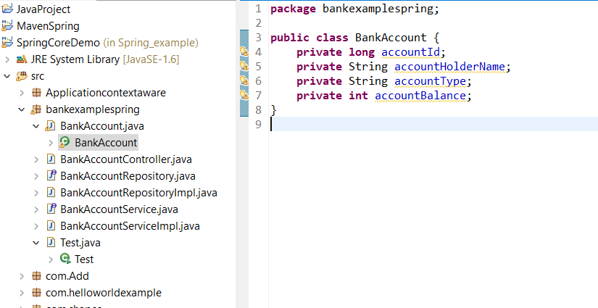

**BankAccountController.java**

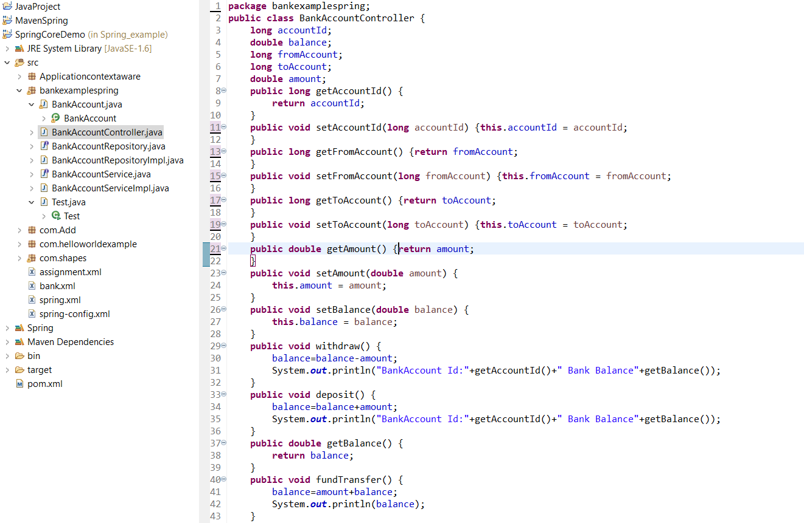

**BankAccountRepo interface**

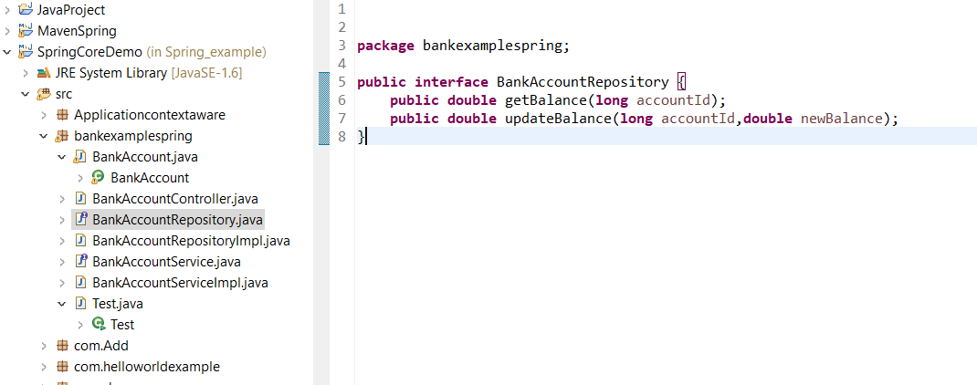

**BankAccountRepositoryImpl.java**

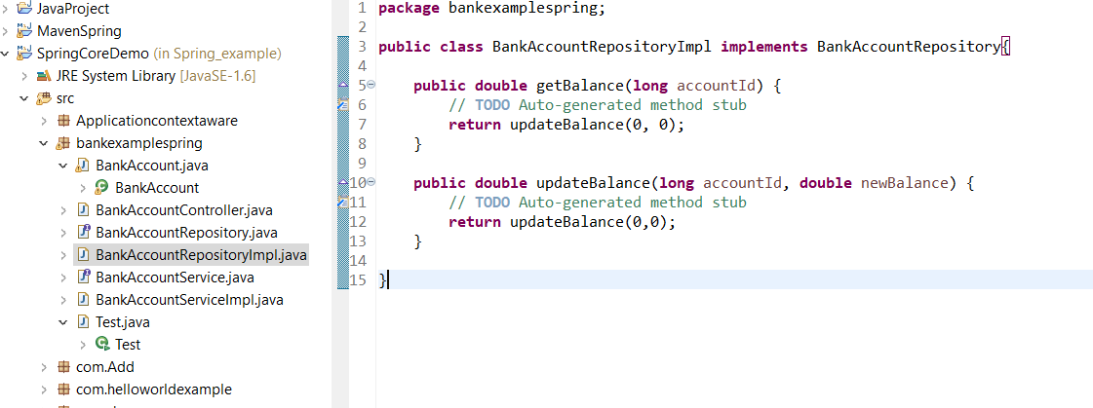

**BankAccountService.java**

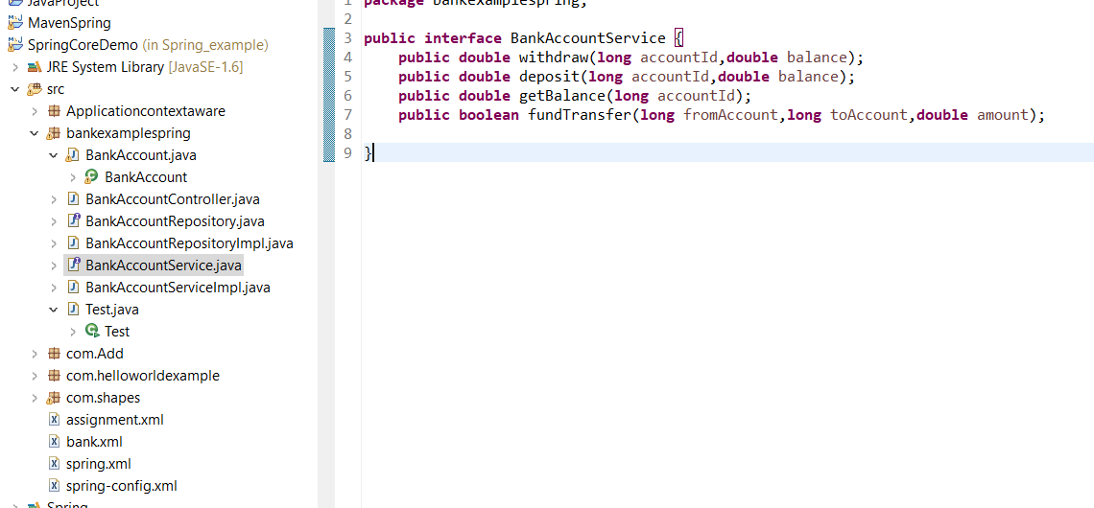

**BankAcccountServiceImpl.java**

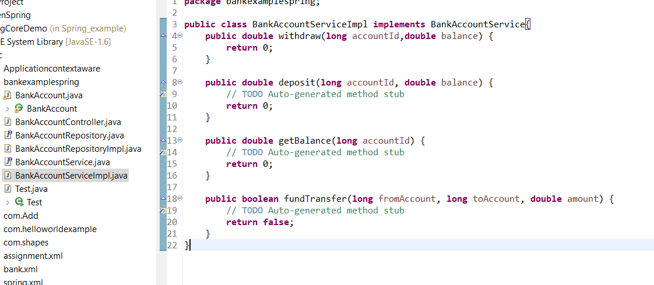

**Test.main**

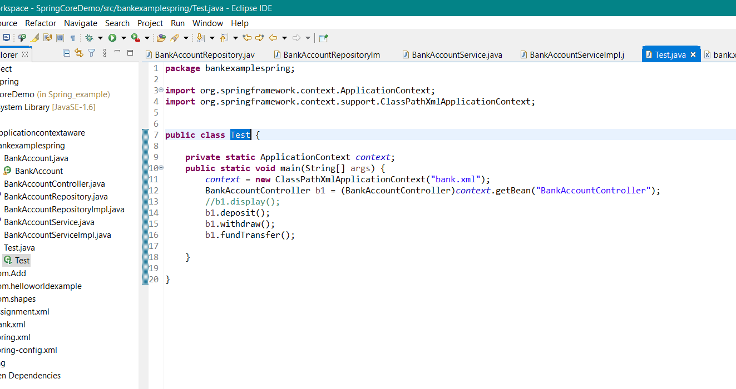

**Bank.xml**

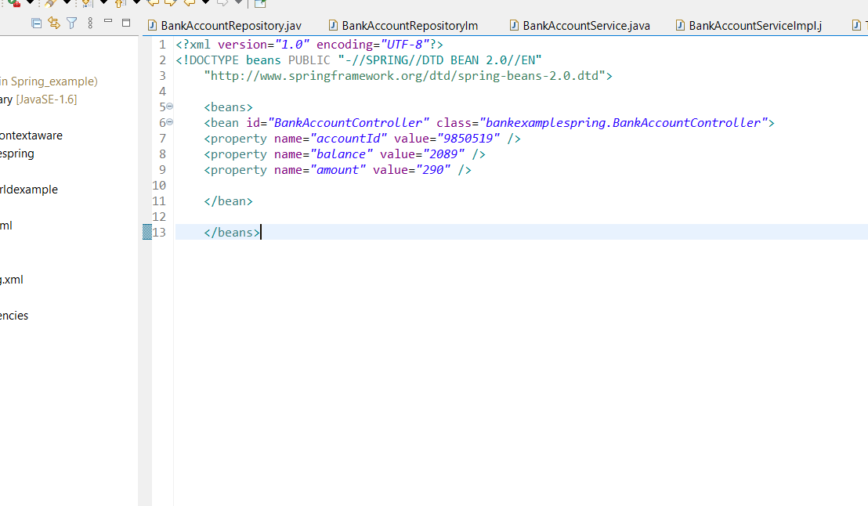

**Output:-**

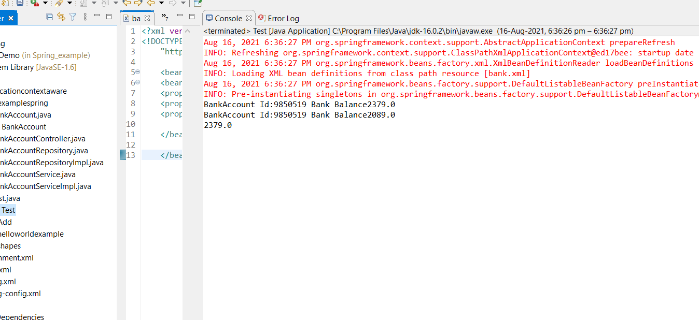

**6)**

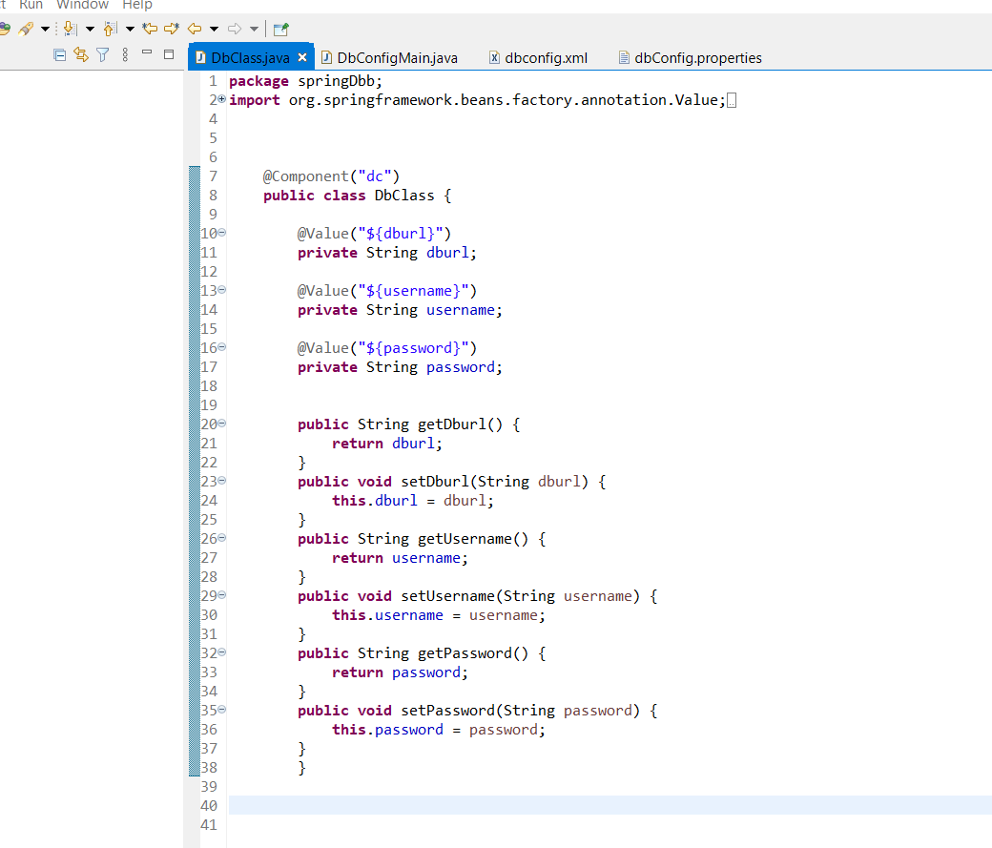

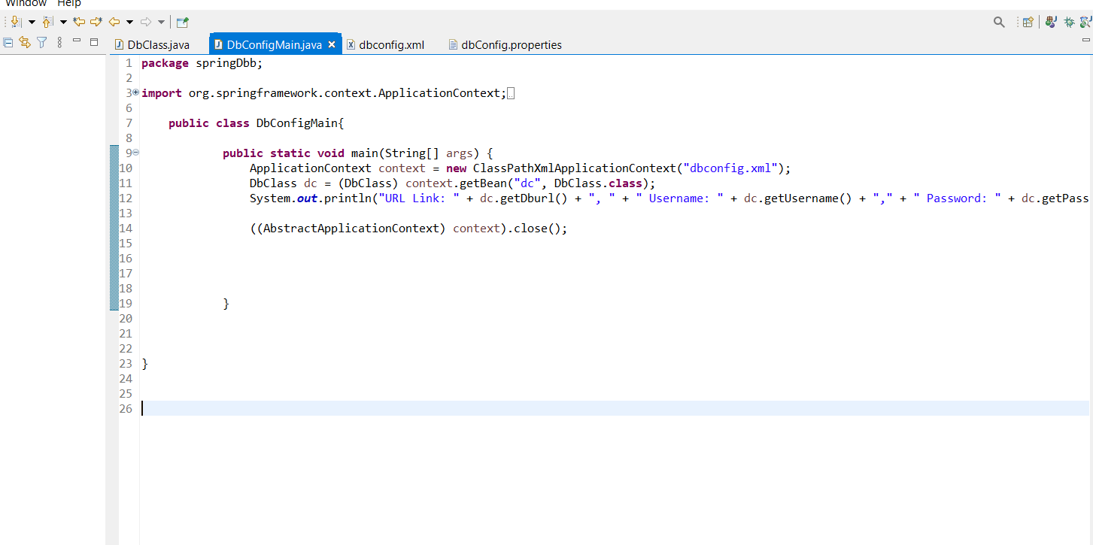

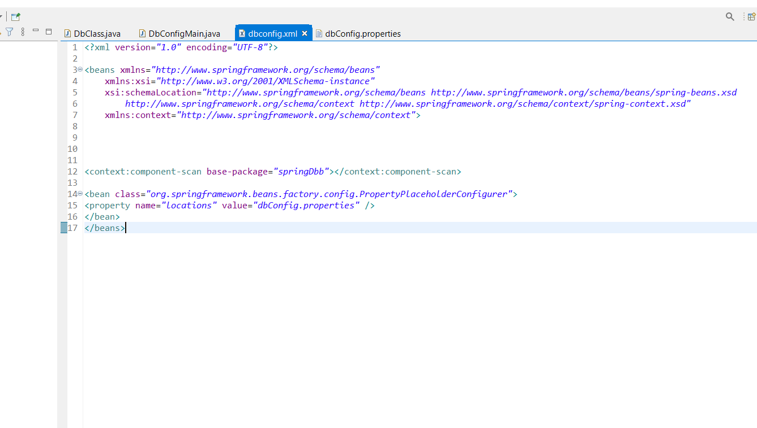

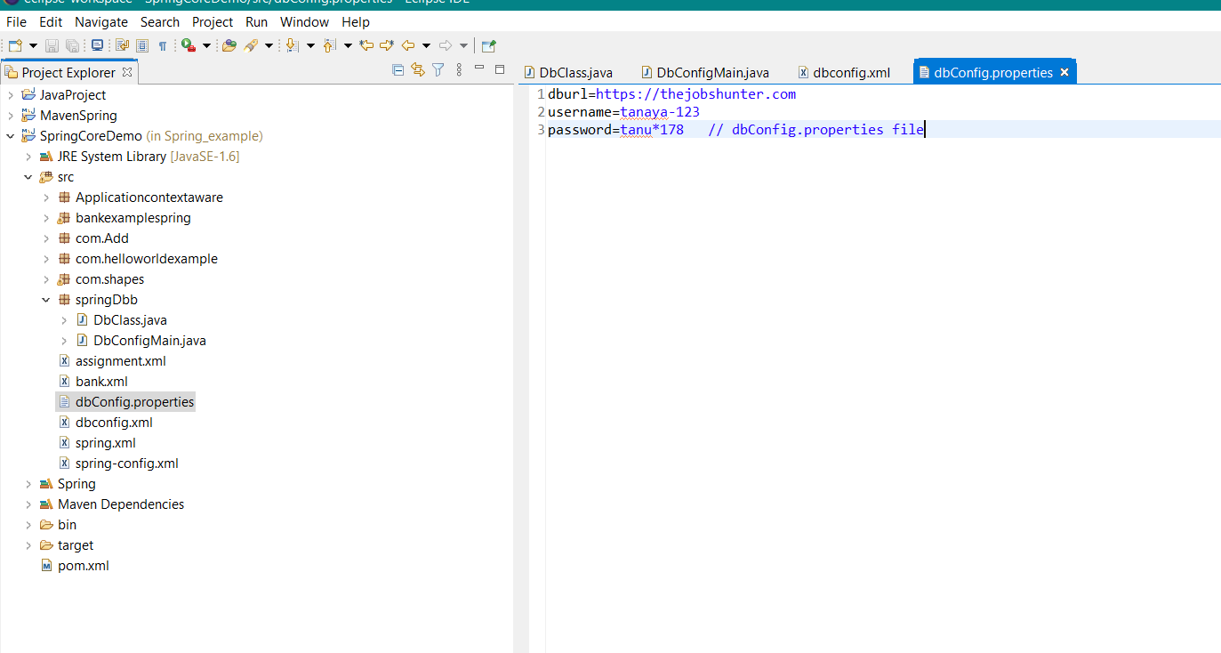

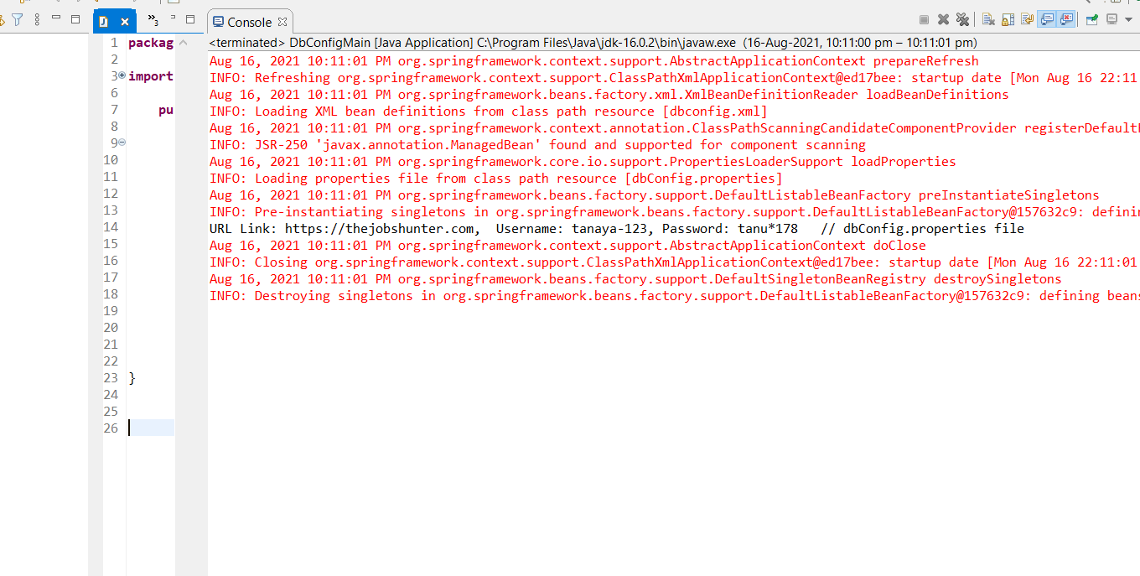

**8) and 9)**

circle.java

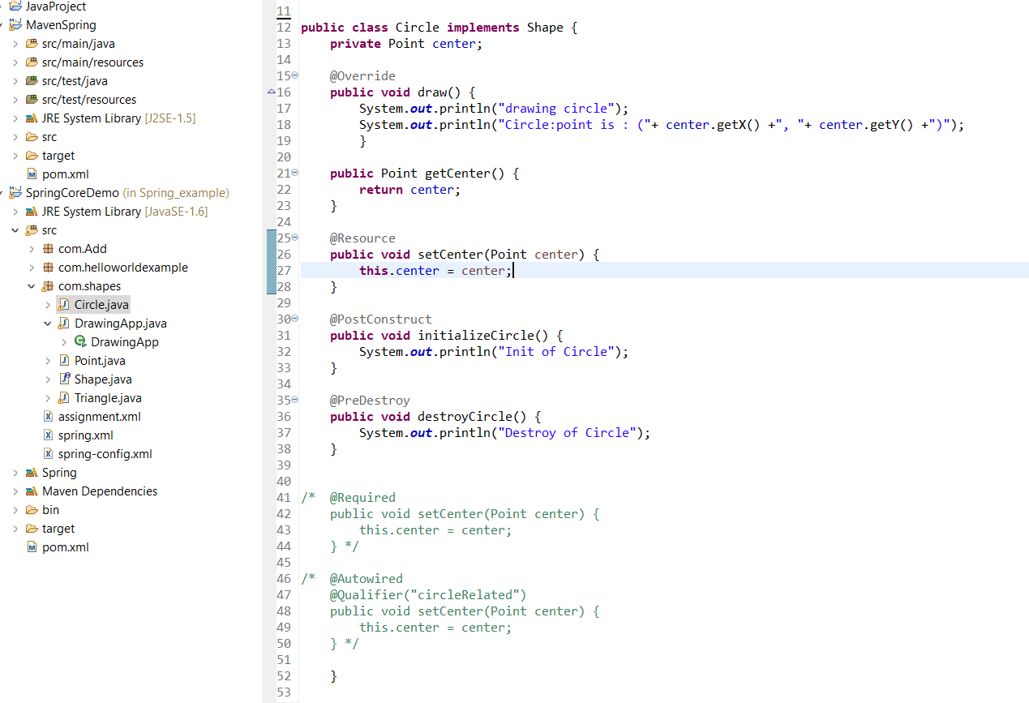

Triangle.java

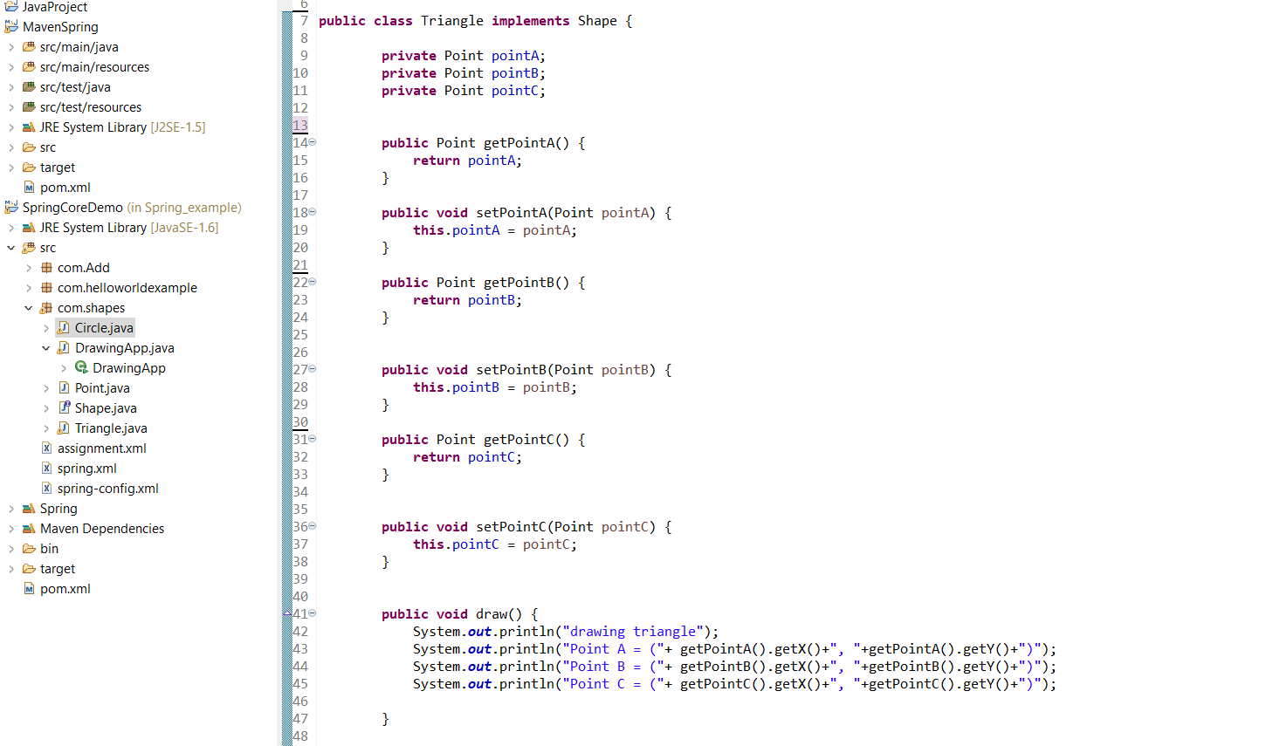

Drawingapp.main

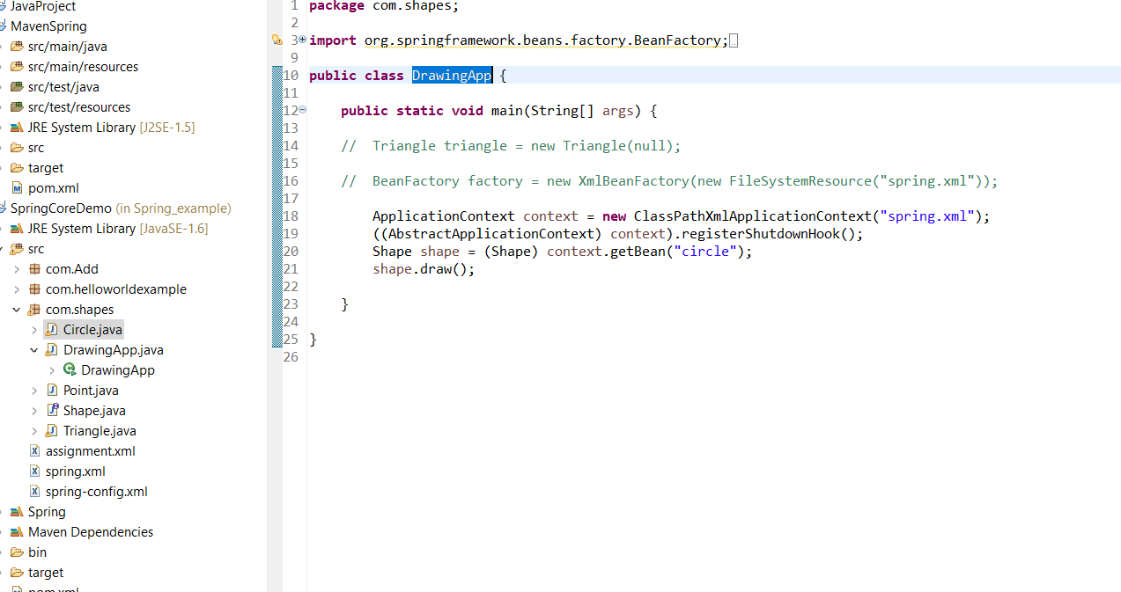

Spring.xml

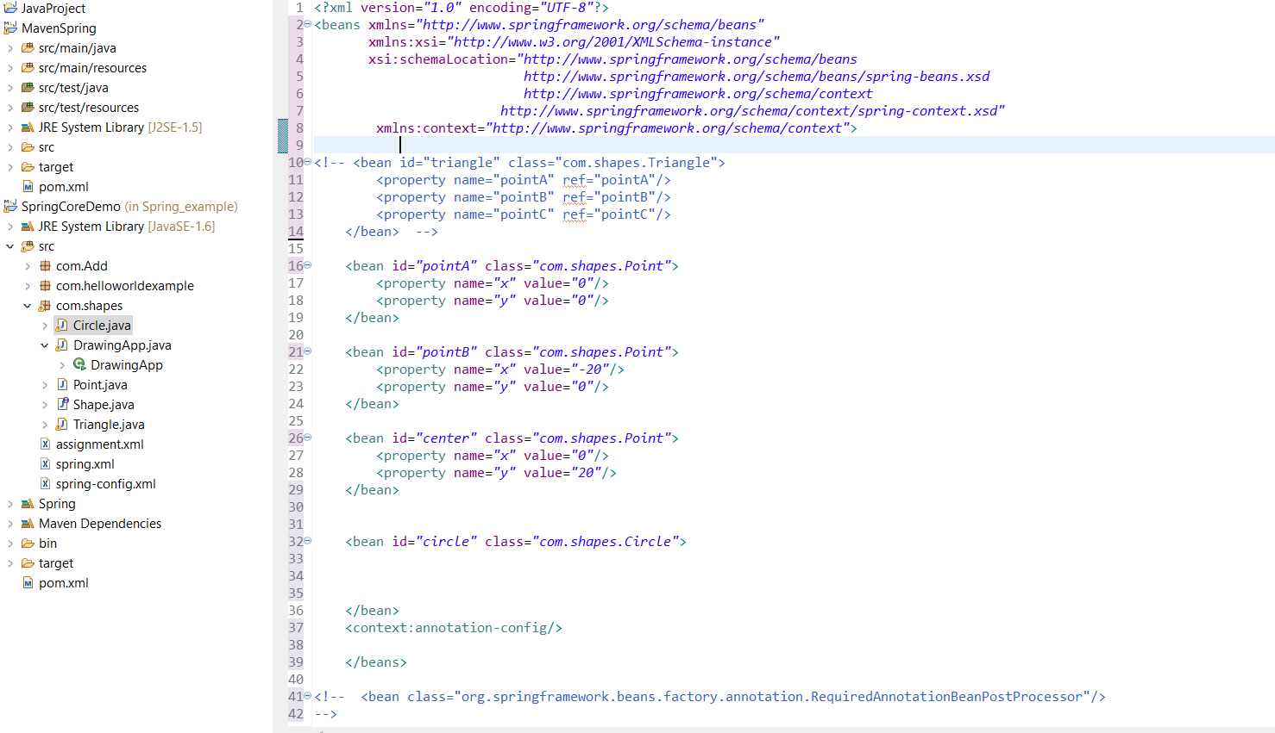

**Output for 8 and 9)**

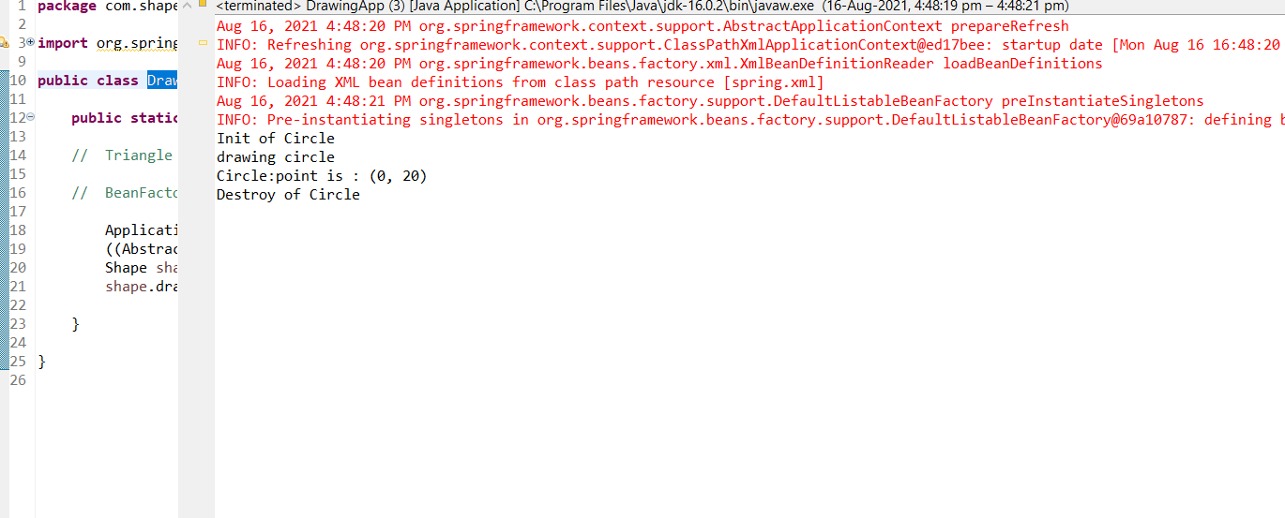

**10)ApplicationContextaware**

**Triangle.java**

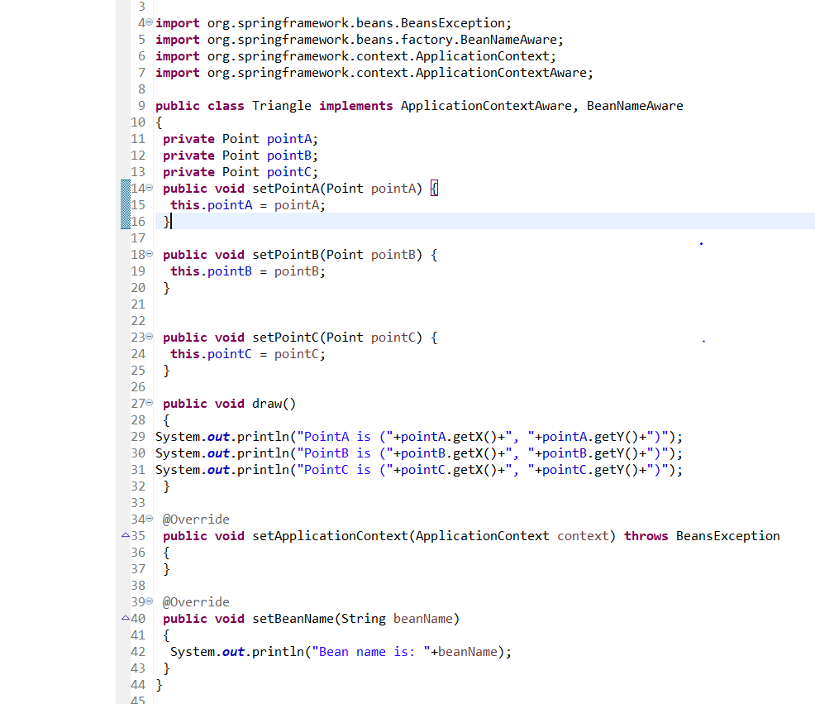

**Point.java**

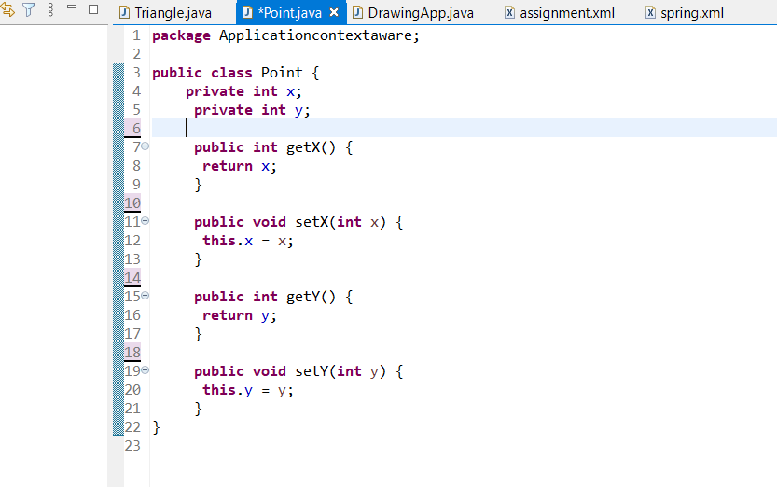

**DrawingApp.main**

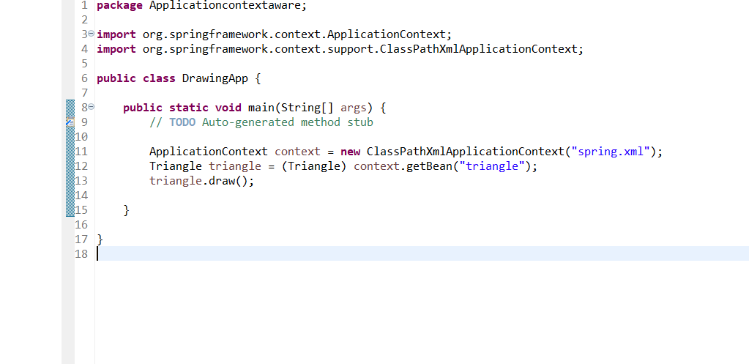

**Spring.xml**

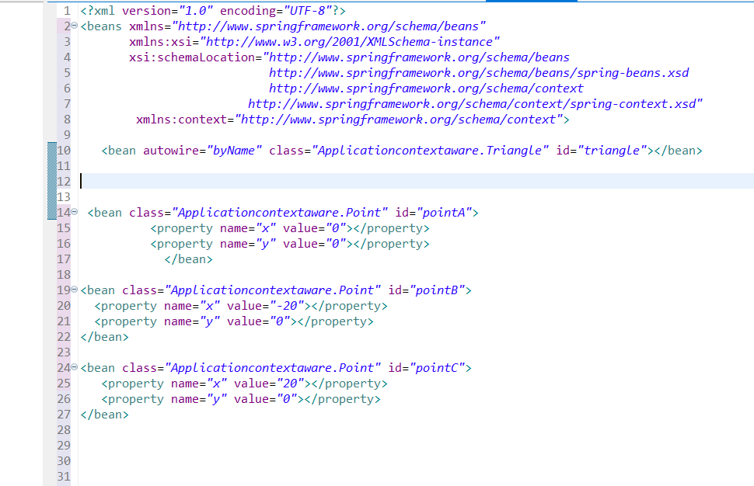

**Output:-**

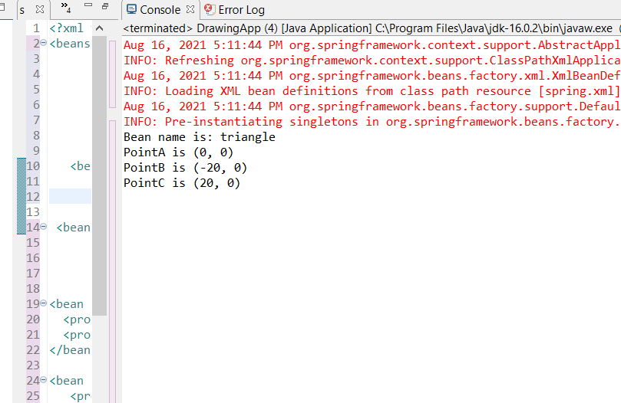

**SPRING MVC**

1)

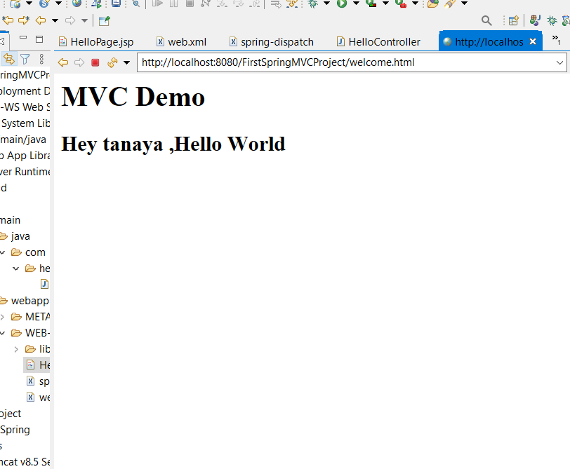

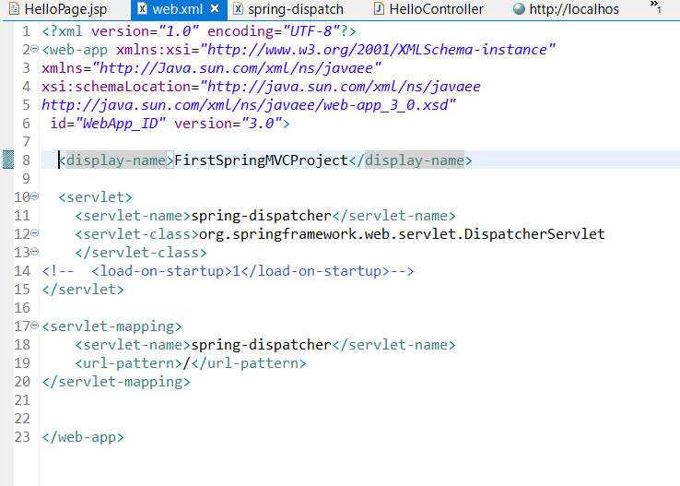

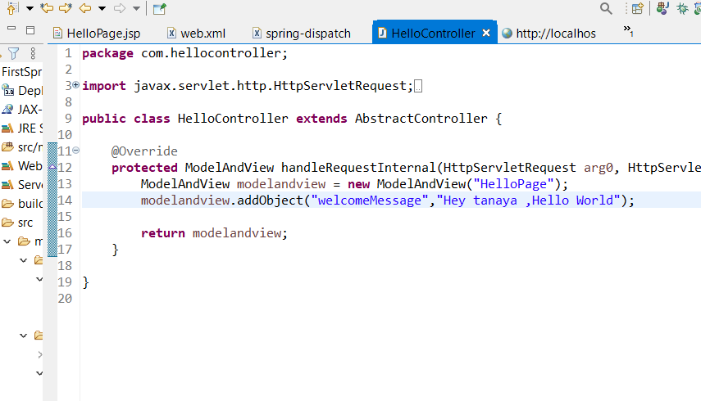

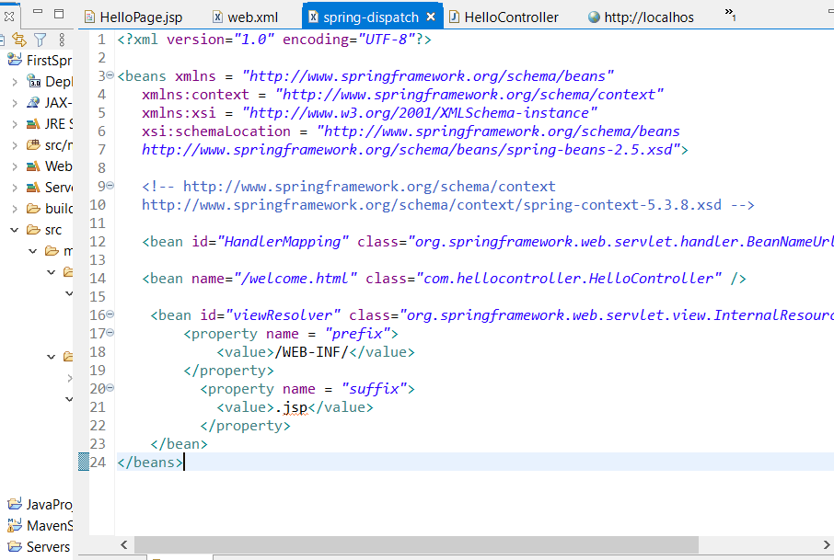

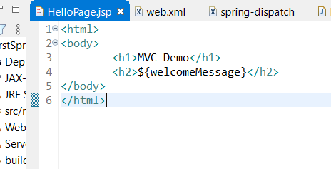

Q)

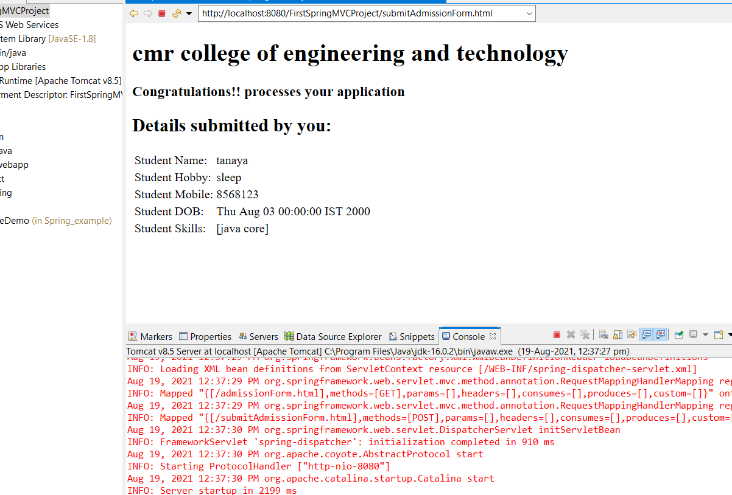

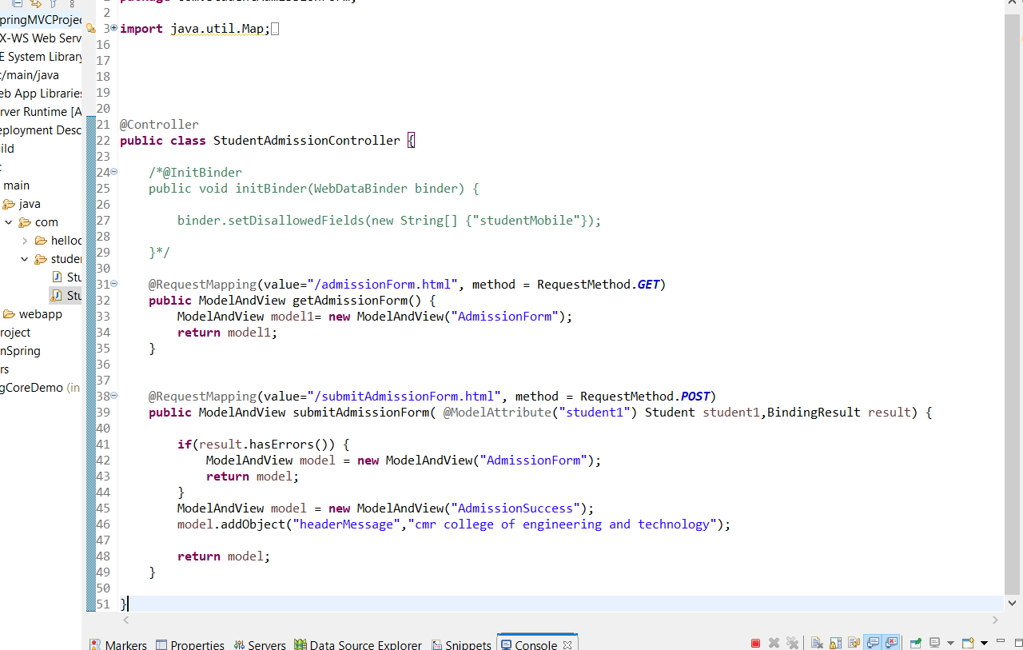

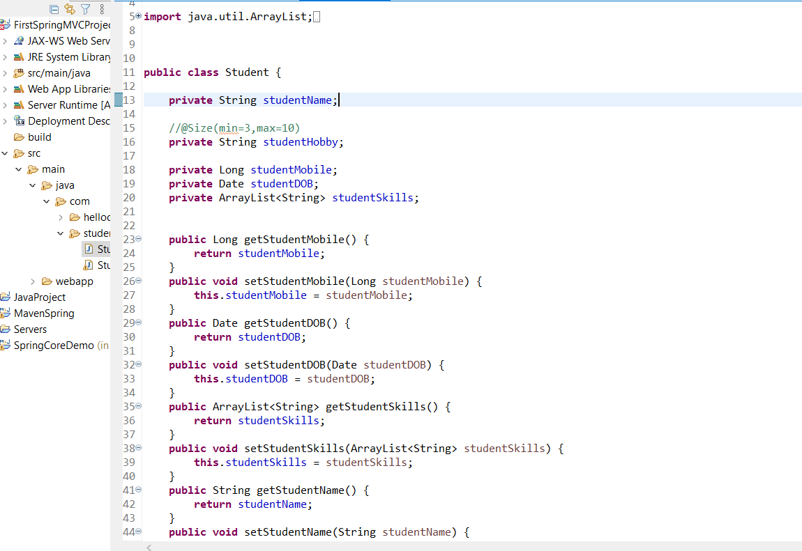

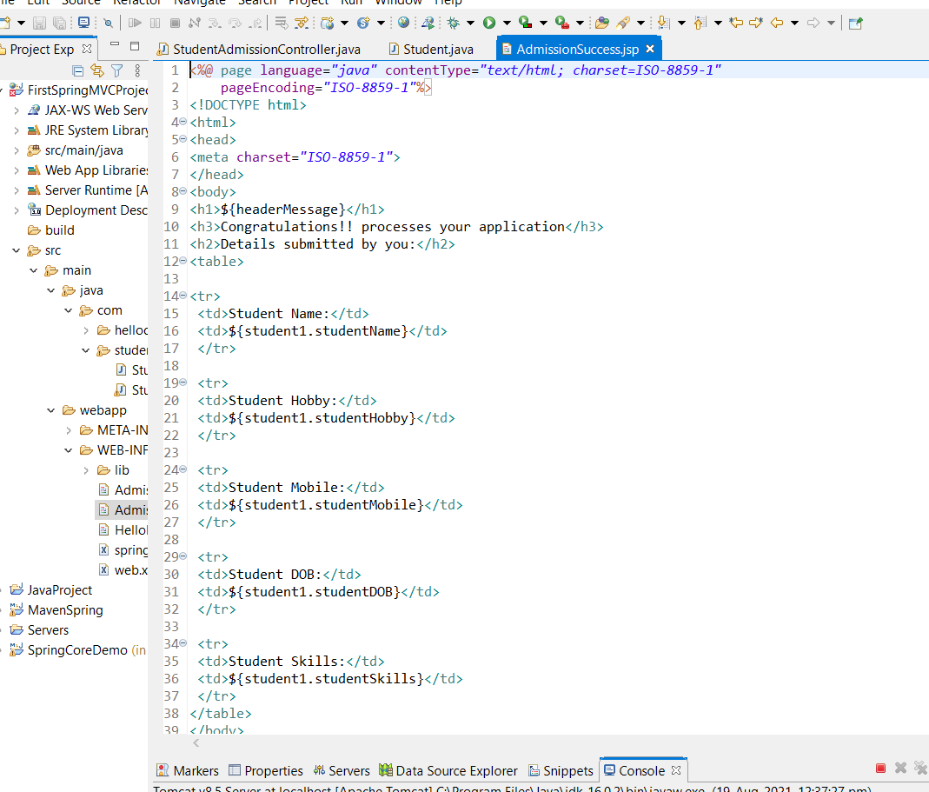

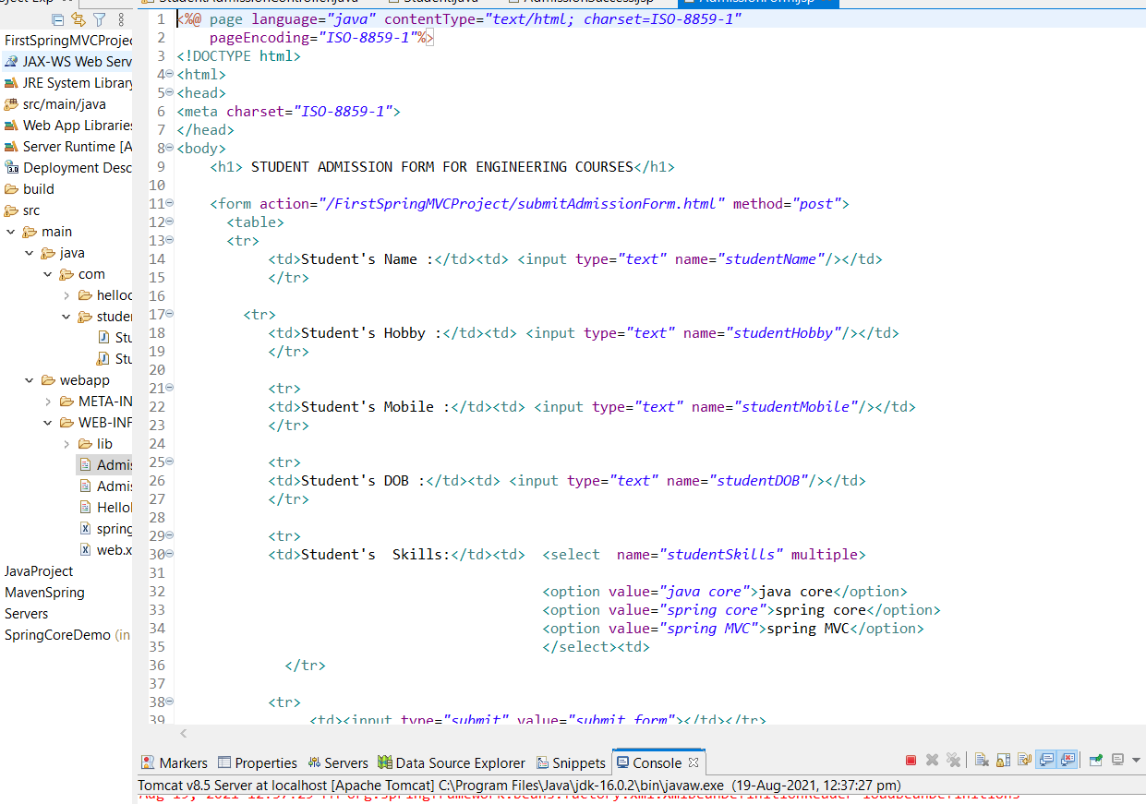

**LOGIN AND AUTHENTICATION**

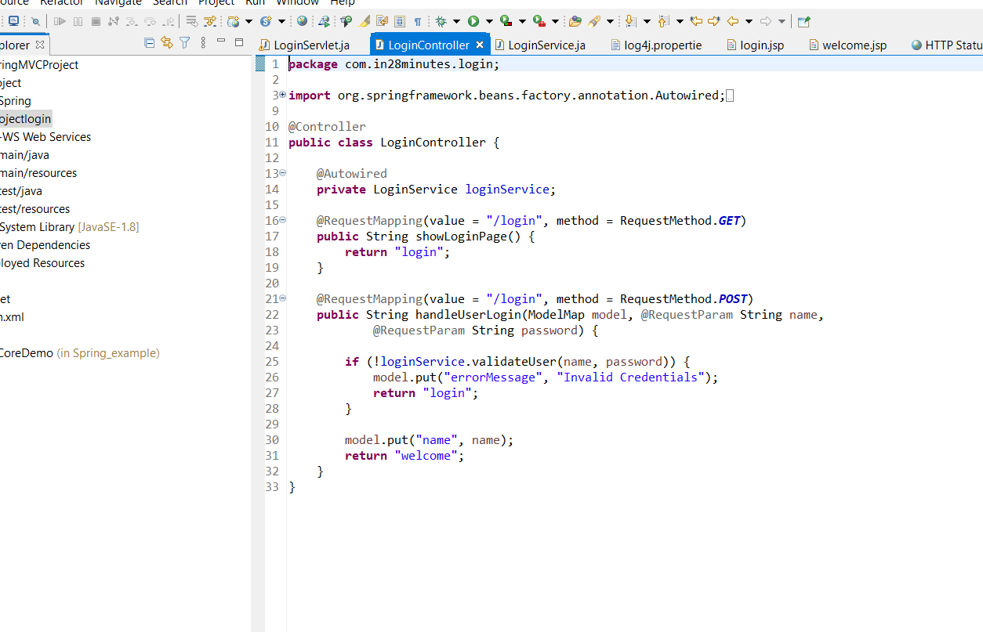

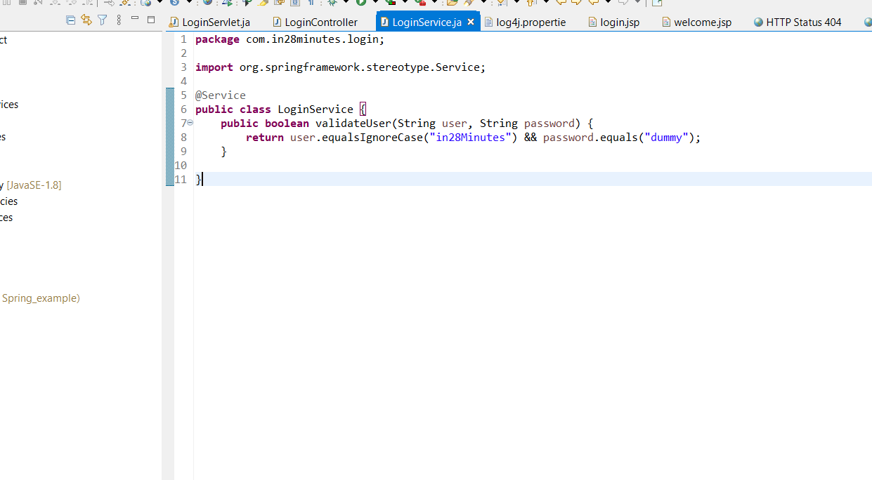

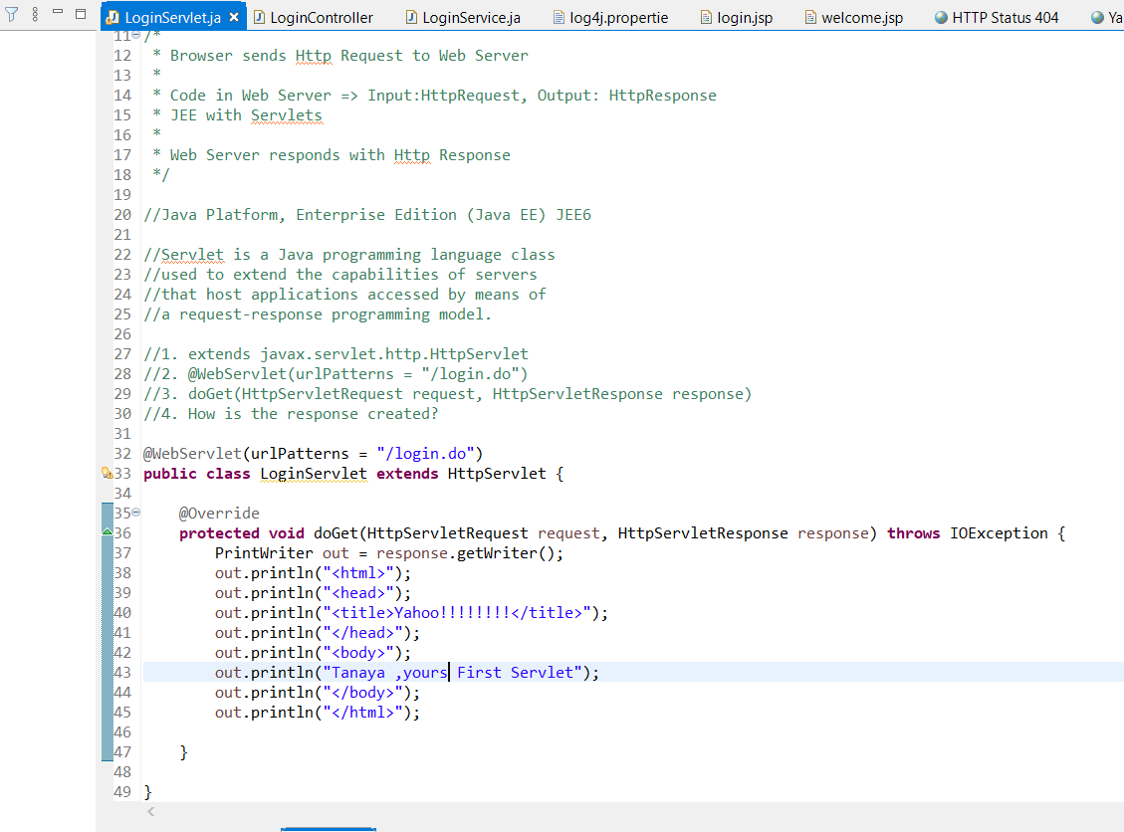

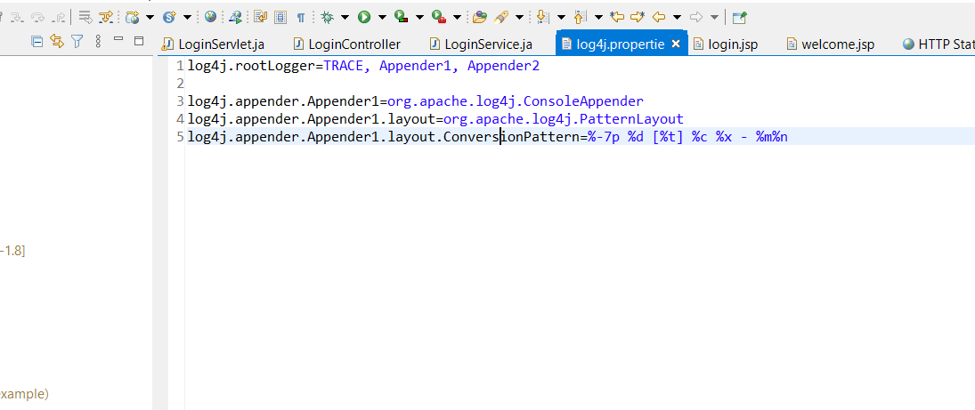

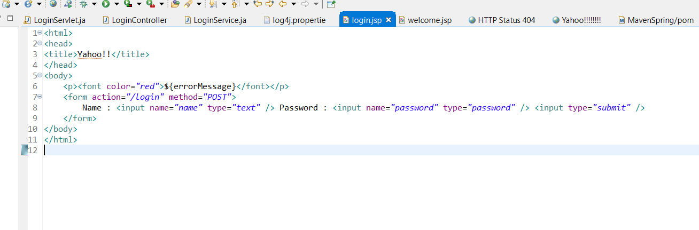

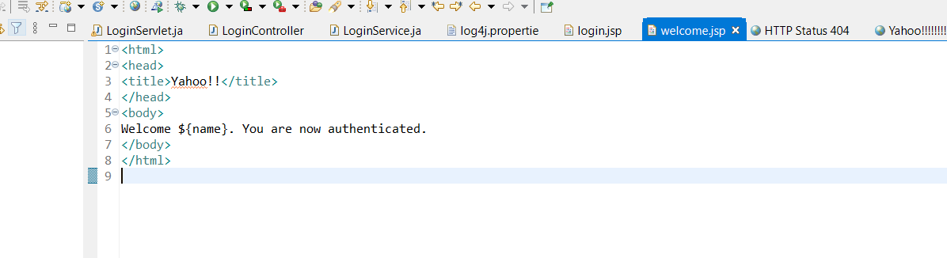

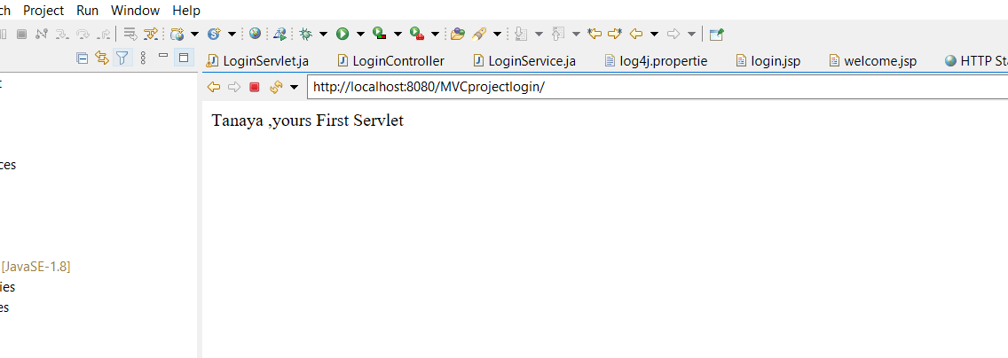

**Q8)**

**[9:15 pm, 20/08/2021] Pragati Mgm: <%@ page language="java" contentType="text/html; charset=ISO-8859-1"**

**pageEncoding="ISO-8859-1"%>**

**<%@ taglib prefix="spring" uri="http://www.springframework.org/tags" %>**

**<html>**

**<head>**

**<title>Spring MVC Form Handling</title>**

**</head>**

**<body>**

**<a href="/FirstSpringMVCProject/customer.html?siteLanguage=en">English</a> |**

**<a href="/FirstSpringMVCProject/customer.html?siteLanguage=fr">French</a>**

**<h2>Customer Information</h2>**

**<form action="/FirstSpringMVCProject/addcustomer.html" method="post">**

**<p>**

**<spring:message code="label.username" /><input type="text" name="name" />**

**</p>**

**<p>**

**<spring:message code="label.passowrd" /><input type="text" name="password" />**

**</p>**

**<p>**

**<spring:message code="label.email" /><input type="text" name="email" />**

**</p>**

**<p>**

**<spring:message code="label.contact" /><input type="text" name="contact" />**

**</p>**

**<p>**

**<spring:message code="label.city" /><input type="text" name="city" />**

**</p>**

**<p>**

**<spring:message code="label.zipcode" /><input type="text" name="zipcode" />**

**</p>**

**<input type="submit" value="Register" />**

**</form>**

**</body>**

**</html>**

**username = Customer Name**

**label.passowrd = Customer Password**

**label.email = Customer Email**

**label.contact =Customer Contact**

**label.city = Customer City**

**label.zipcode = Customer Zipcode**

**label.username = Nom du client**

**label.passowrd = Mot de passe client**

**label.email = Email client**

**label.contact =Contact client**

**label.city = Ville du client**

**label.zipcode = Code postal du client**

**<?xml version="1.0" encoding="UTF-8"?>**

**<beans xmlns = "http://www.springframework.org/schema/beans"**

**xmlns:context = "http://www.springframework.org/schema/context"**

**xmlns:xsi = "http://www.w3.org/2001/XMLSchema-instance"**

**xmlns:mvc="http://www.springframework.org/schema/mvc"**

**xsi:schemaLocation = "http://www.springframework.org/schema/beans**

**http://www.springframework.org/schema/beans/spring-beans-2.5.xsd**

**http://www.springframework.org/schema/context**

**http://www.springframework.org/schema/context/spring-context.xsd**

**http://www.springframework.org/schema/mvc**

**http://www.springframework.org/schema/mvc/spring-mvc-3.0.xsd">**

**<!-- http://www.springframework.org/schema/context**

**http://www.springframework.org/schema/context/spring-context-5.3.8.xsd -->**

**<!-- <bean id="HandlerMapping" -->**

**<!-- class="org.springframework.web.servlet.handler.BeanNameUrlHandlerMapping" /> -->**

**<context:component-scan base-package="com.hellocontroller" ></context:component-scan>**

**<bean name="/welcome" class="com.hellocontroller.HelloController" />**

**<bean name="/admissionForm" class="com.admission.StudentAdmissionController" />**

**<bean name="/customer" class="com.username.CustomerController" />**

**<mvc:annotation-driven/>**

**<bean id="viewResolver" class="org.springframework.web.servlet.view.InternalResourceViewResolver">**

**<property name = "prefix">**

**<value>/WEB-INF/</value>**

**</property>**

**<property name = "suffix">**

**<value>.jsp</value>**

**</property>**

**</bean>**

**<bean id="messageSource" class="org.springframework.context.support.ReloadableResourceBundleMessageSource">**

**<property name="basename" value="/WEB-INF/studentmessages" />**

**</bean>**

**<bean class="org.springframework.web.servlet.i18n.LocaleChangeInterceptor">**

**<property name="paramName" value="siteLanguage" />**

**</bean>**

**<bean id="LocaleResolver" class="org.springframework.web.servlet.i18n.CookieLocaleResolver" />**

**</beans>**

**package com.username;**

**import javax.validation.Valid;**

**import org.springframework.stereotype.Controller;**

**import org.springframework.web.bind.annotation.ModelAttribute;**

**import org.springframework.web.bind.annotation.RequestMapping;**

**import org.springframework.web.bind.annotation.RequestMethod;**

**import org.springframework.web.servlet.ModelAndView;**

**import org.springframework.ui.ModelMap;**

**import org.springframework.validation.BindingResult;**

**@Controller**

**public class CustomerController {**

**@RequestMapping(value = "/customer.html", method = RequestMethod.GET)**

**public ModelAndView customer() {**

**return new ModelAndView("customer", "command", new Customer());**

**}**

**@RequestMapping(value = "/addcustomer.html", method = RequestMethod.POST)**

**public String addStudent(@Valid @ModelAttribute("SpringWeb")Customer customer,**

**ModelMap model,BindingResult br) {**

**if(br.hasErrors())**

**{**

**return "customer";**

**}**

**else {**

**model.addAttribute("name", customer.getUsername());**

**model.addAttribute("password", customer.getPassowrd());**

**model.addAttribute("email", customer.getEmail());**

**model.addAttribute("contact", customer.getContact());**

**model.addAttribute("city", customer.getCity());**

**model.addAttribute("zipcode", customer.getZipcode());**

**return "registration";**

**}**

**}**

**}**

**Q2)**

<?xml version="1.0" encoding="UTF-8"?>   
<beans xmlns="http://www.springframework.org/schema/beans"   
    xmlns:xsi="http://www.w3.org/2001/XMLSchema-instance"   
    xmlns:p="http://www.springframework.org/schema/p"   
    xmlns:context="http://www.springframework.org/schema/context"   
    xsi:schemaLocation="http://www.springframework.org/schema/beans   
http://www.springframework.org/schema/beans/spring-beans-3.0.xsd   
http://www.springframework.org/schema/context   
http://www.springframework.org/schema/context/spring-context-3.0.xsd">   
  
    <context:component-scan base-package="bao"></context:component-scan>  
    <bean class="org.springframework.web.servlet.view.InternalResourceViewResolver">  
    <property name="prefix" value="/uao/"></property>  
    <property name="suffix" value=".jsp"></property>  
    </bean>  
    <bean id="multipartResolver"    
class="org.springframework.web.multipart.commons.CommonsMultipartResolver"/>   
    </beans>  
  
step2nd:-  append code under web.xml file  
  
<?xml version="1.0" encoding="UTF-8"?>  
<web-app xmlns:xsi="http://www.w3.org/2001/XMLSchema-instance" xmlns="http://xmlns.jcp.org/xml/ns/javaee" xsi:schemaLocation="http://xmlns.jcp.org/xml/ns/javaee http://xmlns.jcp.org/xml/ns/javaee/web-app_4_0.xsd" id="WebApp_ID" version="4.0">  
  <display-name>SpringHelloWorldNew</display-name>  
  <welcome-file-list>  
    <welcome-file>index.html</welcome-file>  
    <welcome-file>index.htm</welcome-file>  
    <welcome-file>index.jsp</welcome-file>  
    <welcome-file>default.html</welcome-file>  
    <welcome-file>default.htm</welcome-file>  
    <welcome-file>default.jsp</welcome-file>  
  </welcome-file-list>  
   <servlet>  
    <servlet-name>scs</servlet-name>  
    <servlet-class>org.springframework.web.servlet.DispatcherServlet</servlet-class>  
  </servlet>  
  <servlet-mapping>  
    <servlet-name>scs</servlet-name>  
    <url-pattern>*.html</url-pattern>  
  </servlet-mapping>  
</web-app>

package scsbean;  
  
public class SI {  
private float p;  
private float r;  
private float t;  
public float getP() {  
    return p;  
}  
public void setP(float p) {  
    this.p = p;  
}  
public float getR() {  
    return r;  
}  
public void setR(float r) {  
    this.r = r;  
}  
public float getT() {  
    return t;  
}  
public void setT(float t) {  
    this.t = t;  
}  
  
  
  
}

package bao;  
  
import org.springframework.stereotype.Controller;  
import org.springframework.ui.ModelMap;  
import org.springframework.web.bind.annotation.ModelAttribute;  
import org.springframework.web.bind.annotation.RequestMapping;  
import org.springframework.web.bind.annotation.RequestMethod;  
import org.springframework.web.servlet.ModelAndView;  
  
import scsbean.SI;  
  
@Controller  
public class SIController {  
    @RequestMapping(value = "/si", method = RequestMethod.GET)  
      public ModelAndView siload() {  
        return new ModelAndView("siform", "command", new SI());  
       }  
    @RequestMapping(value = "/silogic", method = RequestMethod.POST)  
      public ModelAndView silogic(@ModelAttribute("SpringWeb")SI s, ModelMap model) {  
           
         float s1 = (s.getP()*s.getR()*s.getT())/100;  
         return new ModelAndView("siresult","res",s1);  
       }  
}

<%@ page language="java" contentType="text/html; charset=ISO-8859-1"  
    pageEncoding="ISO-8859-1"%>  
    <%@taglib uri="http://www.springframework.org/tags/form" prefix="form"%>  
<!DOCTYPE html>  
<html>  
<head>  
<meta charset="ISO-8859-1">  
<title>Insert title here</title>  
</head>  
<body>  
<form:form action="silogic.html" method="POST">       
<table><tbody>  
<tr>        <td><form:label path="p">P :</form:label></td>      <td><form:input path="p"></form:input></td>    </tr>  
<tr>      <td><form:label path="r">R:</form:label></td>       <td><form:input path="r"></form:input></td>    </tr>  
<tr>       <td><form:label path="t">T:</form:label></td>       <td><form:input path="t"></form:input></td>     </tr>  
  
<tr>         <td colspan="2"><input type="submit" value="Submit"/> </td>       </tr>  
</tbody></table>  
</form:form>  
  
  
</body>  
</html>  
  
siresult.jsp  
  
  
<%@ page language="java" contentType="text/html; charset=ISO-8859-1"  
    pageEncoding="ISO-8859-1"%>  
<!DOCTYPE html>  
<html>  
<head>  
<meta charset="ISO-8859-1">  
<title>Insert title here</title>  
</head>  
<body>  
${res}  
</body>  
</html>